
TEMASEK JUNIOR COLLEGE
Preliminary Examinations
Higher 1

CHEMISTRY 8872/01

Paper 1 Multiple Choice 29 September 2009 50 minutes
Additional materials: Multiple Choice Answer Sheet
Data Booklet

READ THESE INSTRUCTIONS FIRST

Write in soft pencil.
Do not use staples, paper clips, highlighters, glue or correction fluid.
Write your name, CG and index number on the Answer Sheet in the spaces provided.

There are thirty questions on this paper. Answer all questions. For each question, there are four possible answers A, B, C, and D.
Choose the one you consider correct and record your choice in soft pencil on the separate Answer Sheet.

Read the instructions on the Answer Sheet very carefully.

Each correct answer will score one mark. A mark will not be deducted for a wrong answer.
Any rough working should be done in this booklet.

This document consists of 13 printed pages.
Section A
For each question there are four possible answers, A, B, C and D. Choose the one you consider to be correct.

1 | How many molecules are present in 1 cm³ of oxygen gas under room conditions?
 | A | 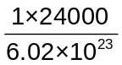
 | B | 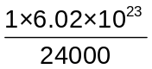
 | C | 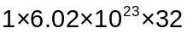
 | D | 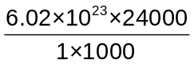

2 | A 0.20 g sample of a monobasic acid requires 8.0 cm³ of 0.40 mol dm⁻³ sodium hydroxide for complete reaction. What is the relative molecular mass of the acid?
 | A | 62.5
 | B | 250
 | C | 625
 | D | 640

3 | Ions of the two most common isotopes of the transition metal nickel are shown below:  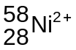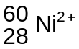  Which one of the following statements is true?
 | A | The electron arrangement of both these Ni²⁺ ions is 1s²2s²2p⁶3s²3p⁶3d⁶4s².
 | B | The ion will have more protons in its nucleus than the ion.
 | C | In the same strength magnetic field, the 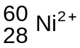ion will be deflected more than the ion.
 | D | Both of these Ni²⁺ ions have the same number of electrons but a different number of neutrons.
4 | Which of the following particles would, on losing an electron, have a half-filled set of p orbitals?
 | A | C⁻
 | B | N
 | C | N⁻
 | D | O⁺

5 | Which of the following conversions involves an oxidation of vanadium (symbol V)?
 | A | VF₅ → V₂O₅
 | B | VO²⁺ → V²⁺
 | C | VO²⁺ → V³⁺
 | D | VO²⁺ → VO₂⁺

6 | When 0.20 mol of hydrogen gas and 0.15 mol of iodine gas are heated at 723 K until equilibrium is established, the equilibrium mixture is found to contain 0.26 mol of hydrogen iodide.  The equation for the reaction is as follows.  H₂(g) + I₂(g) ⇌ 2HI(g)  What is the correct expression for the equilibrium constant K_{c}?
 | A | 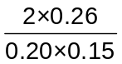
 | B | 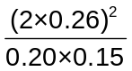
 | C | 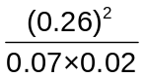
 | D | 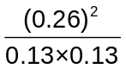

7 | Which set of solutions below will not give a buffer solution when they are mixed?
 | A | 50 cm³ of 0.10 mol dm⁻³ CH₃CO₂H and 50 cm³ of 0.10 mol dm⁻³ CH₃CO₂Na
 | B | 100 cm³ of 0.10 mol dm⁻³ CH₃CO₂H and 50 cm³ of 0.10 mol dm⁻³ NaOH
 | C | 50 cm³ of 0.10 mol dm⁻³ CH₃CO₂Na and 100 cm³ of 0.10 mol dm⁻³ HCl
 | D | 100 cm³ of 0.10 mol dm⁻³ CH₃CO₂Na and 50 cm³ of 0.10 mol dm⁻³ HCl

8 | The following equilibrium exists in a mixture of concentrated nitric acid and concentrated sulphuric acid.  HNO₃ + 2H₂SO₄ ⇌ NO₂⁺ + 2HSO₄⁻ + H₃O⁺  Which statement about this equilibrium is correct?
 | A | Addition of H₂O will reduce the NO₂⁺ concentration .
 | B | HNO₃ and NO₂⁺ are a conjugate acid-base pair.
 | C | The nitric acid acts as an oxidizing agent.
 | D | The sulphuric acid acts as a dehydrating agent.

9 | Substances X, Y and Z react according to the following equation:  X(aq) + 2Y(aq) + Z(aq) → 2W(aq) + U(aq)  To find the rate equation for the above reaction, two sets of separate experiments were performed, in which the initial concentrations of each of the reactants X, Y and Z were varied in turn, the other two being kept constant. The results are shown below.  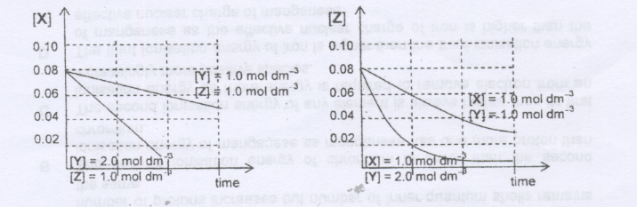  If k is the rate constant, the rate equation is most likely to be
 | A | Rate = k[X][Y][Z]
 | B | Rate = k[X][Y]²[Z]
 | C | Rate = k[Y]²[Z]
 | D | Rate = k[Y][Z]

10 | AlCl₃ reacts with LiAlH₄ and (CH₃)₃NAlH₃. Which statements about (CH₃)₃NAlH₃ is correct?
 | A | It contains hydrogen bonding.
 | B | It is dimeric.
 | C | The Al atom is electron deficient.
 | D | The bonds around the Al atom are tetrahedrally arranged.

11 | Which of the following molecules contains six bonding electrons?
 | A | C₂H₄
 | B | CO₂
 | C | H₂S
 | D | NCl₃

12 | Three substances R, S, T, have physical properties as shown.  What could be the identities of R, S and T?
  substance | mp/ °C | bp/ °C | electrical conductivity
  substance | mp/ °C | bp/ °C | of solid | of liquid
  R | 801 | 1413 | poor | good
  S | 2852 | 3600 | poor | good
  T | 3550 | 4827 | good | not known
   | R | S | T
  A | NaF | KCl | Cu
  B | NaBr | BaO | SiO₂
  C | NaCl | MgO | C (grahite)
  D | NaBr | CaO | C (diamond)

13 | The enthalpy change of formation of the gaseous oxides of nitrogen are positive. This fact is due mainly to
 | A | The tendency of oxygen to form oxide ions.
 | B | The high bond energy of the nitrogen molecule.
 | C | The similarity of the electronegativity of oxygen and nitrogen.
 | D | The high electron affinity of nitrogen.

14 | In which of the following pairs can the two compounds be best distinguished by their different solubilities in water?
 | A | Ethanol and ethanoic acid
 | B | Ethanol and propanone
 | C | Propanone and methylbenzene
 | D | Chloromethane and benzene

15 | In an experiment, 10 cm³ of an organic compound X in the gaseous state was sparked in excess oxygen. 20 cm³ of carbon dioxide and 5 cm³ of nitrogen were obtained among the products. All gas volumes were measured at the same temperature and pressure.  Which of the following compounds could be X?
 | A | C₂H₇N
 | B | C₂H₆N₂
 | C | C₆H₅NO₂
 | D | C₃H₅N

16 | Geraniol has a rose-like odour and is commonly used in perfumes.  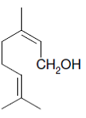  geraniol  Which of the following is not formed when geraniol reacts with hot acidified potassium managanate(VII)?
 | A | 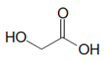
 | B | (CO₂H)₂
 | C | 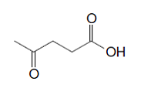
 | D | 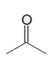

17 | Compound P can be converted to compound Q in a sequence of steps.  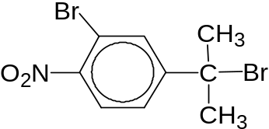  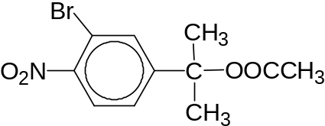  P  Q  Which of the following statement is true?
 | A | The sequential conversion of P to Q involves a nucleophilic substitution reaction, acidic hydrolysis and esterification.
 | B | Compound P must be converted into an alkene first in the first step of conversion to compound Q.
 | C | When hot aqueous alkaline iodine is added to separate samples of P and Q, only compound P forms a yellow precipitate.
 | D | When hot aqueous sodium hydroxide is added separately to compounds P and Q, only compound P gives a pale yellow precipitate with silver nitrate solution.

18 | A compound Z has all of the following properties:  It is a liquid at room temperature and atmospheric pressure;  It does not mix completely with water;  It does not decolorise acidified potassium manganate (VII).  What could compound Z be?
 | A | Ethane
 | B | Ethanoic acid
 | C | Ethanol
 | D | Ethyl ethanoate

19 | Which compound reacts with each of the following  - cold NaOH (aq)  - CH₃OH under reflux with concentrated H₂SO₄  - PCl₅?
 | A | ClCOCOCl
 | B | HO₂CCO₂H
 | C | OHCH₂CO₂CH₃
 | D | ClCOCO₂CH₃

20 | An organic compound has the following properties:  it gives a positive tri-iodomethane (iodoform) test;  it gives a yellow precipitate with 2,4-dinitrophenylhydrazine;  it does not react with either Tollen’s or Fehling’s reagent.  Which compound would give these results?
 | A | CH₃CHO
 | B | CH₃CH₂OH
 | C | CH₃CH₂COCH₃
 | D | CH₃CH₂CH₂CHO

21 | Which statement about ethanal and propanone is incorrect?
 | A | Both can be prepared by the oxidation of an alcohol.
 | B | Both change the colour of warm acidified potassium dichromate (VI) from orange to green.
 | C | Both react with 2,4-dinitrophenylhydrazine reagent.
 | D | Both give a positive tri-iodomethane (iodoform) test.

22 | Which of the following reacts with its own oxidation product (an oxidation which involves no loss of carbon) to give a sweet-smelling liquid?
 | A | Propanal
 | B | Propanoic acid
 | C | Propanone
 | D | Propan-1-ol

23 | Which of the following oxides is unlikely to dissolve in aqueous sodium hydroxide?
 | A | Al₂O₃
 | B | MgO
 | C | P₄O₁₀
 | D | SiO₂

24 | P, Q and R are chlorides of some elements in the Periodic Table.  Which of the following is the correct combination of P, Q and R?  P Q R
   | Observations
   | Reaction of solid with water | Reaction of aqueous solution with aq NaOH
  P | White fumes are liberated | White ppt soluble in excess
  Q | No fumes evolved | No ppt
  R | White fumes are liberated | No ppt
 | A | AlCl₃ NaCl PCl₅
 | B | ZnCl₂ BaCl₂ SiCl₄
 | C | PbCl₂ S₂Cl₂ SiCl₄
 | D | AlCl₃ MgCl₂ PCl₅

25 | The graph below shows the variation in the molar enthalpy change of vapourization for eight consecutive elements in the Periodic Table all with atomic number,Z< 20.  B  ΔH_{vap}  A  H  G  C D E F  Nuclear charge  Which of the following statements is correct?
 | A | Element A is in the same group as beryllium in the Periodic Table.
 | B | Element B forms an oxide which is acidic in aqueous solution.
 | C | Element F exists as diatomic molecules.
 | D | Element G will form amphoteric oxides.

Section B
For each of the questions in this section, one or more of the three numbered statements
1 to 3 may be correct.

Decide whether each of the statements is or is not correct (you may find it helpful to put a tick against the statements which you consider to be correct).

The responses A to D should be selected on the basis of

A | B | C | D
1, 2 and 3  are correct | 1 and 2  only are correct | 2 and 3  only are correct | 1 only is correct
No other combination of statements is used as a correct response.

26 | The use of chlorine as a disinfectant in swimming pools is now widely banned and the weak acid trichloroisocyanuric acid is used instead.  trichloroisocyanuric acid + OH⁻ ⇌ ClO⁻ + cyanuric acid  The ClO⁻ ion is the effective disinfectant.
 | Why is it necessary to keep the pH of the water at 7.5?
 | 1 | The concentration of H⁺ is too low for the following reaction to occur;  2H⁺(aq) + ClO⁻(aq) + Cl⁻(aq) ⇌ H₂O(l) + Cl₂(g)
 | 2 | The concentration of the ClO⁻ ion depends on the pH
 | 3 | At a pH of 7.5, the concentration of the ClO⁻ ion is at a maximum

27 | Magnesium oxide and sodium fluoride are isoelectronic (have the same number of electrons).  Which of the following are reasons why the value of the lattice energy of magnesium oxide is four to five times that of sodium fluoride?
 | 1 | The lower electrostatic forces of attraction between the doubly charged ions
 | 2 | The higher electrostatic forces of attraction between the doubly charged ions
 | 3 | The shorter internuclear distance between the doubly charged ions

28 | The reaction between KI(aq) with excess Na₂S₂O₈(aq) was studied and the following graph was obtained.  [I₂]  C∞  time  Where C∞ is the maximum concentration of I₂  What information may be obtained from the graph above?
 | 1 | The rate of reaction at any given instant
 | 2 | Order of reaction with respect to I⁻
 | 3 | Order of reaction with respect to S₂O₈^{2─}

29 | Which of the following compounds produce effervescence of carbon dioxide gas when they are reacted with hot acidified potassium manganate(VII)?
 | 1 | CH₃-CH=CH₂
 | 2 | HO₂C-CO₂H
 | 3 | HO-CH₂-CHO

30 | Which of the following set of reagents and conditions can be used to form the organic product CH₃-CH(OH)-CH₂-CO₂H from CH₃-CO-CH₂-CO₂H?
 | 1 | LiAlH₄, dry ether as solvent, room temperature
 | 2 | H₂, nickel catalyst at 140 ºC
 | 3 | Zinc in dilute hydrochloric acid

